2.1.1 Archive and Age Database

Brief Description
This use case models the required interactions between the System Operator and the Trading Engine software when the trade and order data is archived to the database (CST, RAT, ORT) and aged. It also sets the system up for a new trading session by providing the clearfile function.

Flow of Events

Basic Flow
- Systems operations enters the command to Archive and Age Database.
- The system validates the request.
- The system performs the archive function.
- The system logs that the archive function has completed.
- The system begins the age function.
- The system logs that the age function has completed.
- The system responds to the operators.

Alternative Flows

System not eligible to Archive and Age Database
- System operations enters the command to Archive and Age Database
- The system validates the request.
- The system responds with an error indicating that Archive and Age Database cannot be run. The response includes the reason. (function not complete, trading not stopped, etc.).

Operator needs to stop the Archive and Age Database
- System operations enters the command to stop the archive and age database function.
- The system validates the request.
- The system stops the function.
- The system logs that the function was stopped.

Operator needs to restart the Archive and Age Database function
- System operations enters the command to restart the function.
- The system validates the request.
- The system restarts the function.
- The system logs that the function was restarted.

Relationships

Actors:
System Operations Staff
Class Series Receiver
RAES Activity Receiver
Order History Receiver

Uses and extends associations with:

Use-Case Diagrams

Archive and Age Database
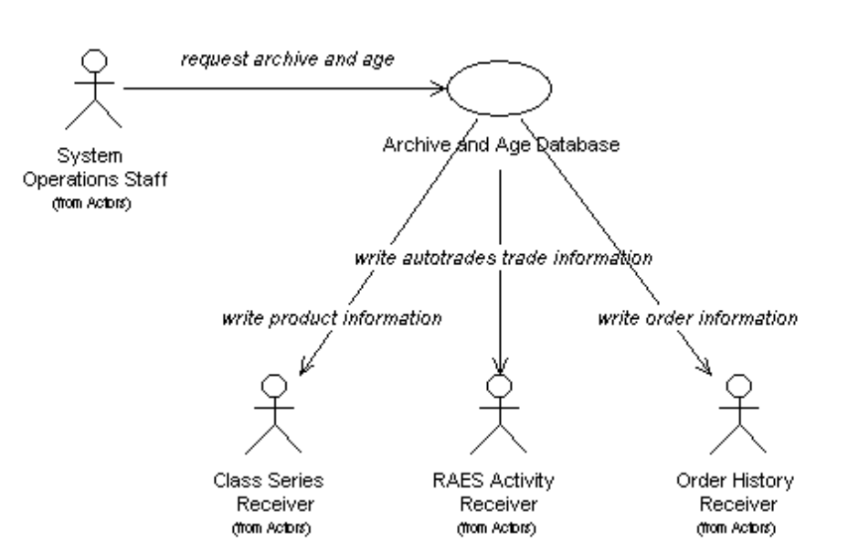

Special Requirements

Performance
- This function must complete within xx minutes of being started.

Security
- The command to initiate this process can only be entered from the operators console.

Preconditions
- Trading has been stopped.
- Disseminate End of Day Summary has been run.
- The front door has been closed.

Postconditions
- All processes dependent upon Archive and Age Database can be run.

Pictures of the User Interface
<<include pictures of the user interface>>

2.1.2 Close Front Door

Brief Description
This use case models the required interactions between the System Operator and the Trading Engine software when shutdown of COMPASS is requested.

Flow of Events

Basic Flow
- The system operations staff initiates the Compass shutdown from the system console.
- The system closes the connection with Compass.

Alternative Flows

Compass System unavailable
- The system tries to bring the Compass connection down the Compass connection is down.
- The system notifies the systems operations staff that the shutdown not available.

Relationships

Actors:
System Operations Staff
COMPASS

Uses and extends associations with:

Use-Case Diagrams

Close Front Door UCD
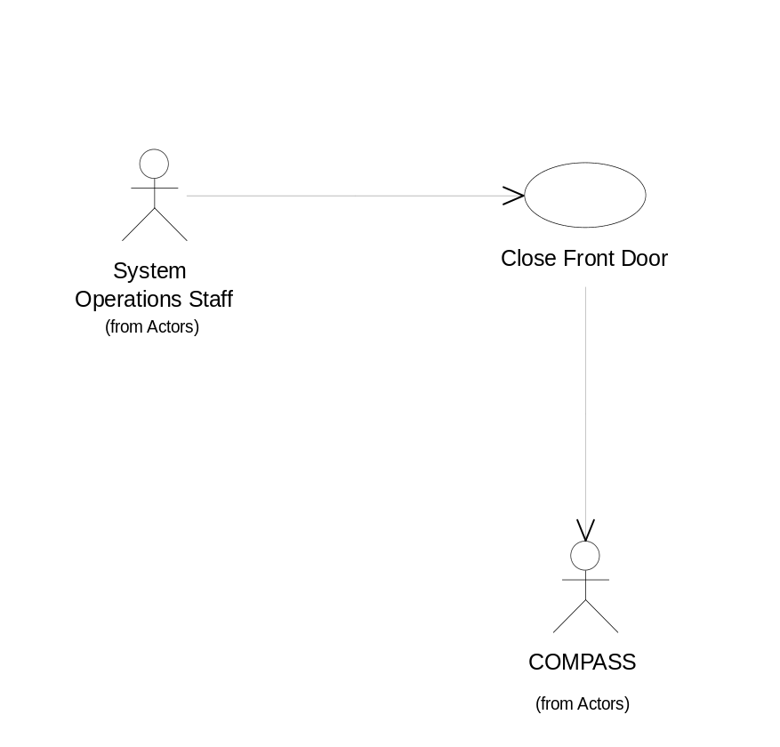

Special Requirements

Performance

Security

Preconditions

The compass connection is active.

Postconditions

The system is no longer able to receive wire orders.

Pictures of the User Interface

2.1.3 Display Audit Log

Brief Description
This use case models the required interactions between the System Operator and the Trading Engine software when the audit log is displayed.

Flow of Events

Basic Flow
- The Systems Operator selects the Display Audit Log template function
- The system brings up the system audit log in reverse chronological order (most recent entry at the top.)
- The operator selects the scroll up and down functions.
- The system scrolls the log display the appropriate amount.

Alternative Flows

Relationships

Actors:
System Operations Staff

Uses and extends associations with:

Use-Case Diagrams

Display Audit Log UCD
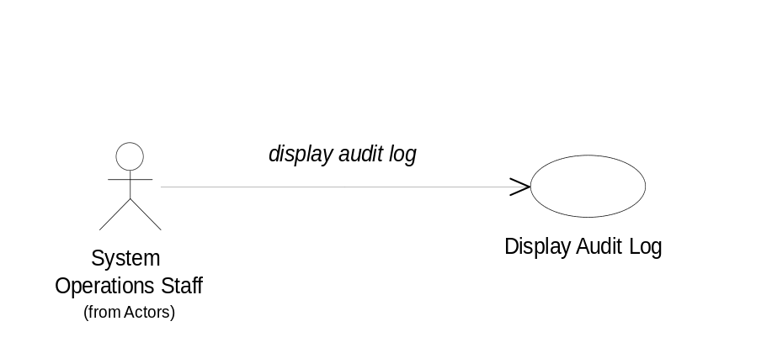

Special Requirements

Performance

Security

Preconditions

Postconditions

Pictures of the User Interface

2.1.4 Disseminate AutoTrader Eligible Products

Brief Description
This use case models the required interactions between the System Operator and the Trading Engine software when AutoTrader is sent eligible product.

Flow of Events

Basic Flow
- Systems operations enters the command to disseminate the Auto Trader eligible products.
- The system runs through all products and checks to see if they are Auto Trader eligible.
- For all products Auto Trader eligible, the system formats and sends a message to the COPP system.
- When all products have been checked, the system sends a response back to the operators.

Alternative Flows

Relationships

Actors:
System Operations Staff
COPP

Uses and extends associations with:

Use-Case Diagrams

Disseminate AutoTrader Eligible Products UCD
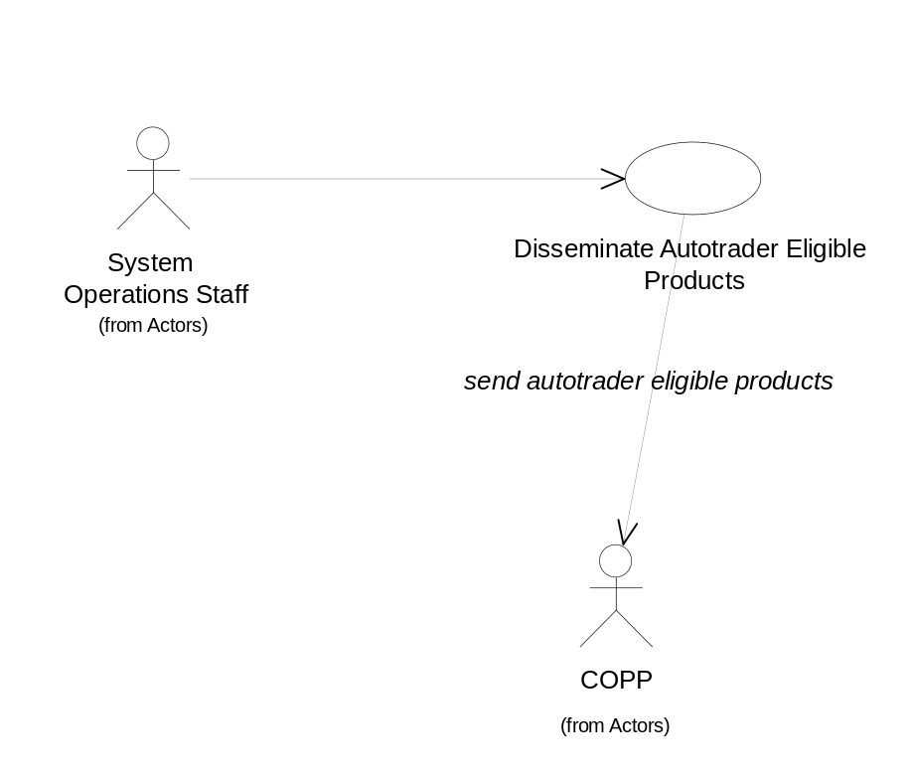

Special Requirements

Performance
- The system needs to be able disseminate the eligible products within xx seconds.

Security
- The command to initiate this process can only be entered from the operators console.

Preconditions
- Trading has not been started
- The trading engine has established a connection with COPP.

Postconditions
- All processes dependent upon the Auto Trader eligible dissemination can not be started.

Pictures of the User Interface

2.1.5 Disseminate End of Day Summary

Brief Description
This use case models the required interactions between the System Operator and the Trading Engine software when End of Day Summary is distributed.

Flow of Events

Basic Flow
- Systems operations enters the command to Disseminate End of Day Summary.
- The system validates the request.
- The system gathers the end of day summary information.
- The system creates the end of day summary report
- The system sends the end of day summary report to all receivers
- The system logs that the Disseminate End of Day Summary has completed.
- The system responds to the operators.

Alternative Flows

System not eligible to Disseminate End of Day Summary
- System operations enters the command to Disseminate End of Day Summary
- The system validates the request.
- The system responds with an error indicating that Disseminate End of Day Summary cannot be run. The response includes the reason (function not complete, trading not stopped, etc.).

Relationships

Actors:
System Operations Staff
COPP
EEOD

Uses and extends associations with:

Use-Case Diagrams

Disseminate End of Day Summary UCD
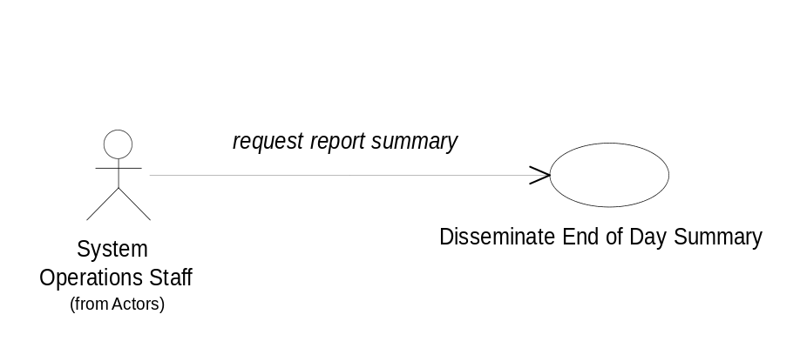

Special Requirements

Performance

Security
- The command to initiate this process can only be entered from the operators console.

Preconditions
- Trading has been stopped.

Postconditions
- All processes dependent upon Disseminate End of Day Summary can be run.

Pictures of the User Interface

2.1.6 Disseminate Hourly Reports

Brief Description
This use case models the required interactions between the News Wire and COPP and the Trading Engine software when hourly summaries are distributed.

Flow of Events

Basic Flow
- The system begins the Disseminate Hourly Reports automatically based on time of day
- The system validates the request.
- The system gathers the hourly information
- The system creates the hourly reports
- The system sends the hourly reports to all receivers.
- The system logs that the Disseminate Hourly Reports has completed for the current hour.

Alternative Flows

System not eligible to Disseminate Hourly Reports
- The system begins the Disseminate Hourly Reports automatically based on time of day
- The system validates the request.
- The system determines that the hourly reports cannot be disseminated and logs the fact along with the reason (function not complete, trading not started, etc.).

Relationships

Actors:
COPP
News Wire

Uses and extends associations with:

Use-Case Diagrams

Disseminate Hourly Reports UCD
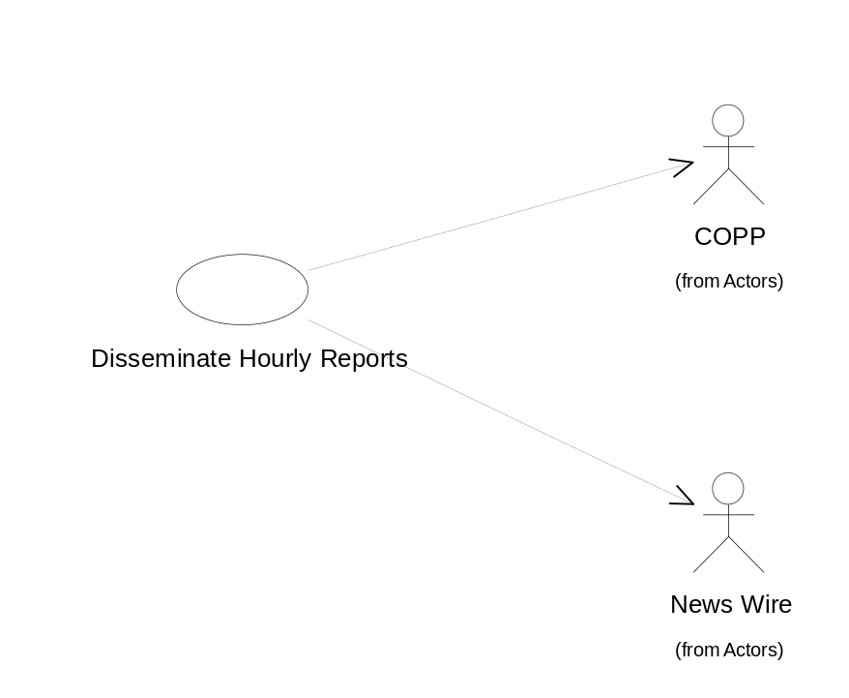

Special Requirements

Performance

Security
- The command to initiate this process can only be entered from the operators console.

Preconditions
- Trading has been started.

Postconditions

Pictures of the User Interface

2.1.7 Enter BART Force Logoff

Brief Description
This use case models the required interactions between the System Operator and the Trading Engine software when logoff is forced for BART.

Flow of Events

Basic Flow
- The Systems Operator selects the BART Control Template
- The system brings up the BART Control Template
- The operator enters a BART workstation ID and selects the Force Logoff option.
- The system validates that the workstation is logged in.
- The system displays a confirmation dialog.
- The operator confirms the force logoff.
- The system sends a force logoff to the BART system for the specified workstation with the following information.
- Transaction code
- Transaction sub code
- Server ID
- Workstation ID
- Date
- Time
- The system prints all orders that are marked as being on the specified BART workstation.
- The system logs a message indicating that the specified workstation was forced logged off and includes the number of printed orders.
- The system clears the confirmation dialog, redisplays the BART Control Template, and responds to the operators with a transaction complete response.

Alternative Flows

Operator Enters Invalid Workstation ID
- The Operator enters an invalid BART workstation ID and selects the Force Logoff option.
- The system responds with an error message indicating that the workstation ID is invalid.
- The Operator corrects the workstation ID and resends the request.
- The system processes the request.

Operator Enters a Workstation ID that is not logged in.
- The Operator enters a BART workstation ID and selects the Force Logoff option.
- The system responds with an error message indicating that the workstation is not logged in.
- The Operator corrects the workstation ID and resends the request.
- The system processes the request.

Operator Decides to Cancel from confirmation dialog.
- The systems displays a confirmation dialog.
- The operator selects cancel from the confirmation dialog.
- The system clears the confirmation dialog, and redisplays the BART Control Template.

Relationships

Actors:
System Operations Staff
BART

Uses and extends associations with:

Use-Case Diagrams

Enter BART Force Logoff UCD
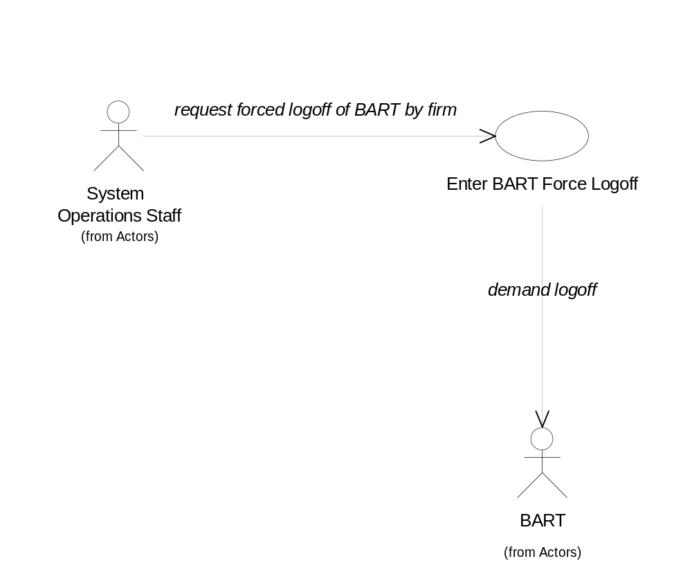

Special Requirements

Performance

Security
- BART Force Logoffs can only be performed from the operators terminal.

Preconditions

Postconditions

Workstation marked as logged out
The specified BART workstation is marked as being logged out. This prevents any more orders from being sent to the workstation until the workstation is logged back in.

Pictures of the User Interface

2.1.8 Enter OPRA Text Messages

Brief Description
This use case models the required interactions between the System Operator and the Trading Engine software when OPRA text messages are sent to COPP.

Flow of Events

Basic Flow
- The Systems Operator selects the OPRA Text Message Template
- The System displays the template.
- The Systems Operator enters the OPRA Text Message.
- The System logs the text message to the audit log and sends it to OPRA via COPP

Alternative Flows

Relationships

Actors:
System Operations Staff
COPP

Uses and extends associations with:

Use-Case Diagrams

Enter OPRA Text Messages UCD
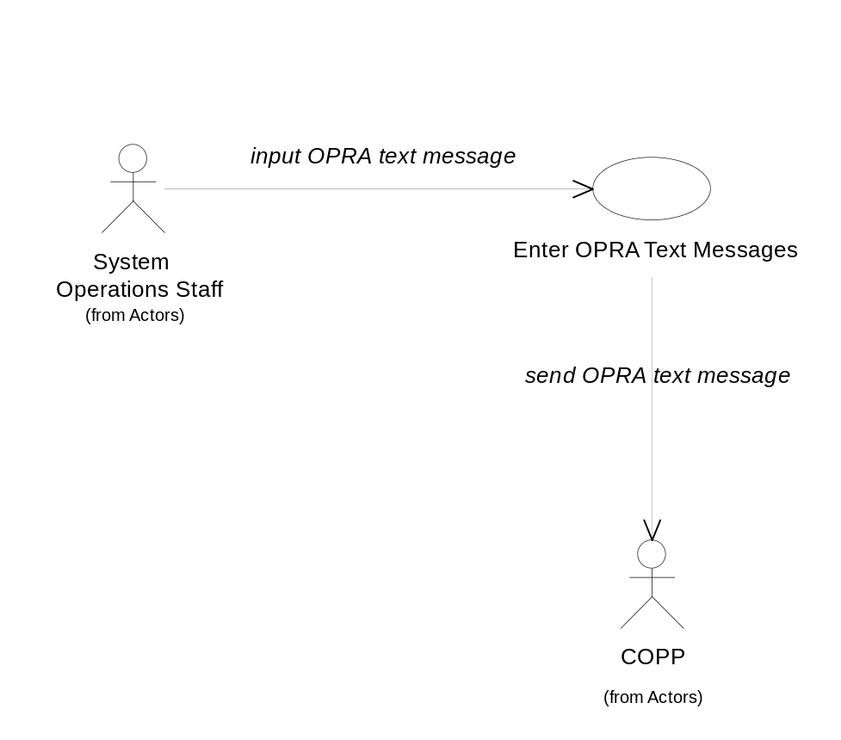

Special Requirements

Performance

Security

Preconditions

Connection with COPP has been established

Postconditions

Pictures of the User Interface

2.1.9 Enter PAR Force Logoff

Brief Description
This use case models the required interactions between the System Operator and the Trading Engine software when logoff is forced for PAR.

Flow of Events

Basic Flow
- The Systems Operator selects the PAR Control Template
- The system brings up the PAR Control Template
- The operator enters a PAR workstation ID and selects the Force Logoff option.
- The system validates that the workstation is logged in.
- The system displays a confirmation dialog.
- The operator confirms the force logoff.
- The system sends a force logoff to the PAR system for the specified workstation with the following information.
- Transaction code
- Transaction sub code
- Server ID
- Workstation ID
- Date
- Time
- The system prints all orders that are marked as being on the specified PAR workstation.
- The system logs a message indicating that the specified workstation was forced logged off and includes the number of printed orders.
- The system clears the confirmation dialog, redisplays the PAR Control Template, and responds to the operators with a transaction complete response.

Alternative Flows

Operator Enters Invalid Workstation ID
- The Operator enters an invalid PAR workstation ID and selects the Force Logoff option.
- The system responds with an error message indicating that the workstation ID is invalid.
- The Operator corrects the workstation ID and resends the request.
- The system processes the request.

Operator Enters a Workstation ID that is not logged in.
- The Operator enters a PAR workstation id and selects the Force Logoff option.
- The system responds with an error message indicating that the workstation is not logged in.
- The Operator corrects the workstation ID and resends the request.
- The system processes the request.

Operator Decides to Cancel from confirmation dialog.
- The systems displays a confirmation dialog.
- The operator selects cancel from the confirmation dialog.
- The system clears the confirmation dialog, and redisplays the PAR Control Template.

Relationships

Actors:
System Operations Staff
PAR

Uses and extends associations with:

Use-Case Diagrams

Enter PAR Force Logoff UCD
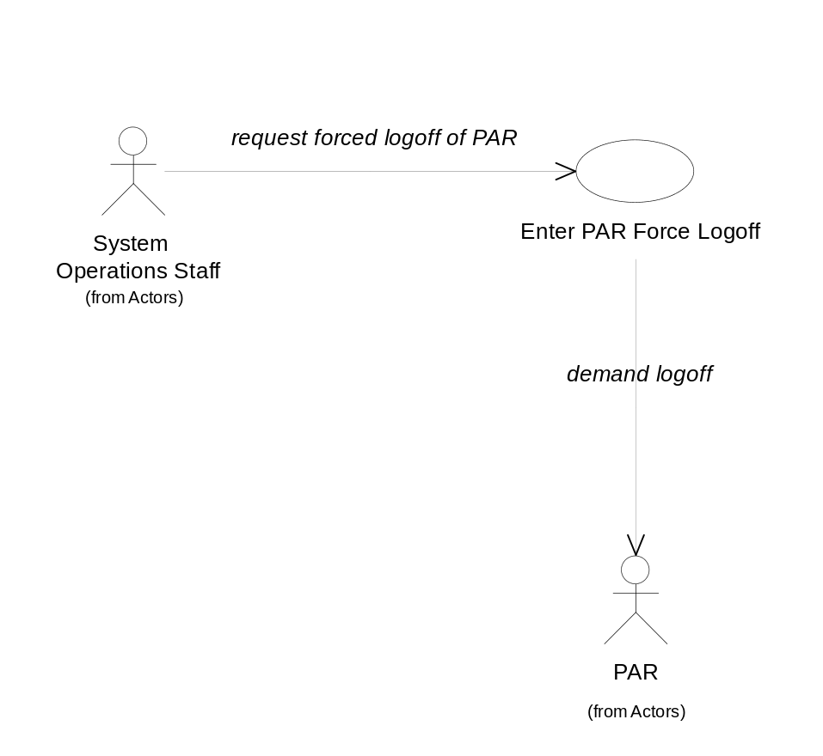

Special Requirements

Performance

Security
- PAR Force Logoffs can only be performed from the operators terminal.

Preconditions

Postconditions

Workstation marked as logged out
The specified PAR workstation is marked as being logged out. This prevents any more orders from being sent to the workstation until the workstation is logged back in.

Pictures of the User Interface

2.1.10 Enter Product Open Interest

Brief Description
This use case models the required interactions between the System Operator and the Trading Engine software when the open interest is read into the system.

Flow of Events

Basic Flow
- The system operations staff receives the open interest tape from the OCC in the following format:
- Option ID????
- Open Interest????
- The system operations staff initiate the open interest update process in the system.
- The system reads the open interest data from the OCC tape. For each open interest item read, the system performs the following steps.
- Validates the product
- Updates the product with the new open interest value.

Alternative Flows

Open interest read for an unknown product
- An open interest item contains an unknown product.
- The system generates an alert message indicating that the open interest item is invalid and notifies the system operations staff.

Relationships

Actors:
OCC
System Operations Staff

Uses and extends associations with:

Use-Case Diagrams

Enter Product Open Interest
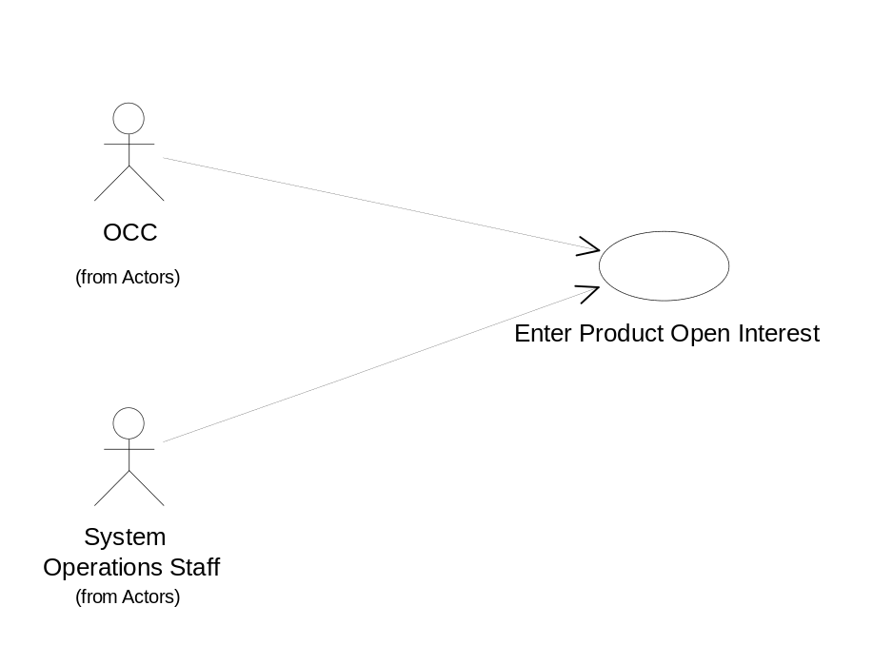

Special Requirements

Performance
- The system needs to be able to complete the open interest update process within xx minutes.

Security

Preconditions

Postconditions

The system enters the open interest update complete state.

Pictures of the User Interface

2.1.11 Initialize EB Backup

Brief Description
This use case models the required interactions between the System Operator and the Trading Engine software for backup of EBOO.

Flow of Events

Basic Flow
- Systems operations enters the command to initialize EB backup.
- The system validates the request.
- The system initializes the EB backup system.
- The system logs that the EB backup system has been initialized
- The system responds to the operators.

Alternative Flows

Relationships

Actors:
System Operations Staff
EB Backup

Uses and extends associations with:

Use-Case Diagrams

Initialize EB Backup UCD
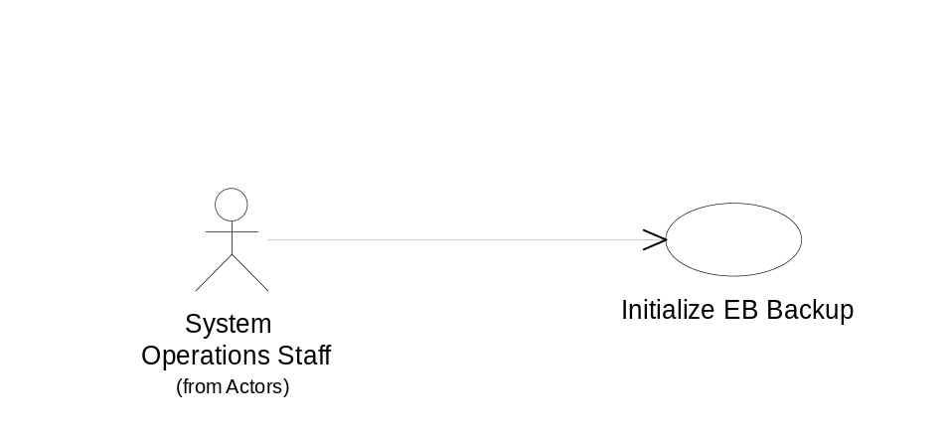

Special Requirements

Performance

Security
- The command to initiate this process can only be entered from the operators console.

Preconditions

Postconditions

Pictures of the User Interface

2.1.12 Open Front Door

Brief Description
This use case models the required interactions between the System Operator and the Trading Engine software when startup of COMPASS is requested.

Flow of Events

Basic Flow
- The system operations staff initiates the Compass startup from the system console.
- The system establishes a connection with Compass.

Alternative Flows

Compass System unavailable
- The system tries to establish connection with Compass prior to Compass being brought up.
- The system times out the connection attempt and notifies the systems operations staff that the startup failed.

Relationships

Actors:
COMPASS
System Operations Staff

Uses and extends associations with:

Use-Case Diagrams

Open Front Door
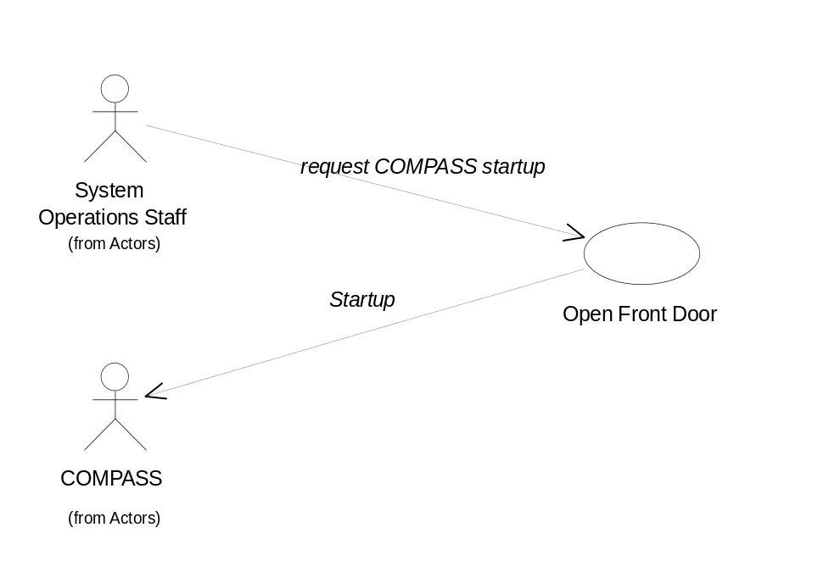

Special Requirements

Performance

Security

Preconditions

Postconditions

The system is now able to receive wire orders.

Pictures of the User Interface

2.1.13 Request External System Shutdown

Brief Description
This use case models the required interactions between the System Operator and the Trading Engine software when shutdown is requested for external systems (BART, PAR).

Flow of Events

Basic Flow
- The System Operator enters the Request External System Shutdown command from the system console.
- The system validates the request.
- The system sends the shutdown request to each external system.
- The system logs the fact that the external systems have been notified to shutdown.
- The system responds to the operators indicating that the external shutdowns have been initiated.
- The system receives shutdown complete messages from external systems.
- The system logs the shutdown complete messages from external systems.
- The system sends a notification to the operators for each shutdown complete message.

Alternative Flows

System not eligible to Request External System Shutdown
- The System Operator enters the Request External System Shutdown command from the system console.
- The system validates the request.
- The system determines that Request External System Shutdown cannot be run and logs the fact along with the reason (function not complete, trading not stopped, etc.).

Relationships

Actors:
System Operations Staff
PAR
BART

Uses and extends associations with:

Use-Case Diagrams

Request External System Shutdown UCD
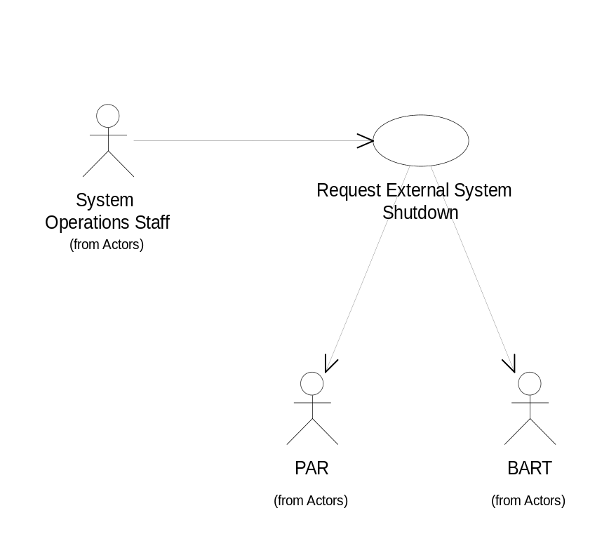

Special Requirements

Performance
- The Request External System Shutdown process must be completed within xx minutes from the time it is initiated.

Security
- The command to initiate this process can only be entered from the operators console.

Preconditions
- Trading has been stopped.

Postconditions

Pictures of the User Interface

2.1.14 Set Market Conditions

Brief Description

Flow of Events

Basic Flow
- The Help Desk Staff request the set market conditions template from the system
- The system displays the set market conditions template.
- The user enters the market conditions and selects update.
- The system validates the market conditions.
- The system logs the market condition change
- The system displays the market conditions on the floor
- The system disseminates the market conditions to OPRA through COPP
- The system responds to the user with a transaction processed message.

Relationships

Actors:
Help Desk Staff

Uses and extends associations with:

Use-Case Diagrams

Set Market Conditions UCD
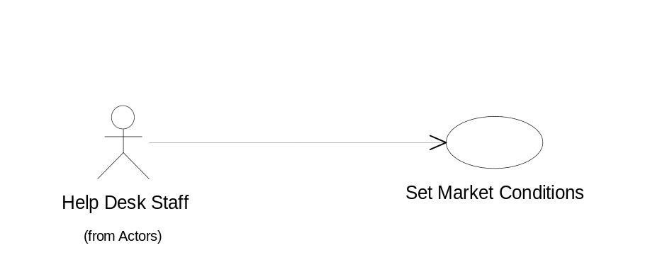

Special Requirements

Performance

Security
- The Set Market Conditions function can only be performed from a terminal in the Help Desk or the Systems Operations Area.

Preconditions

Postconditions

Pictures of the User Interface

2.1.15 Start Trading

Brief Description
This use case models the required interactions between the System Operator and the Trading Engine software when trading is started.

Flow of Events

Basic Flow
- Systems operations enters the command to start trading.
- The system validates the request.
- The system enters the trading state.
- The system logs that trading has started.
- The system responds to the operators.

Alternative Flows

System not eligible to enter trading state.
- System operations enters the command to start trading.
- The system validates the request.
- The system responds with an error indicating that trading cannot be started. The response includes the reason trading cannot be started (files locked, disseminate auto trader eligible products not complete, etc.).

Relationships

Actors:
System Operations Staff

Uses and extends associations with:

Use-Case Diagrams

Start Trading UCD
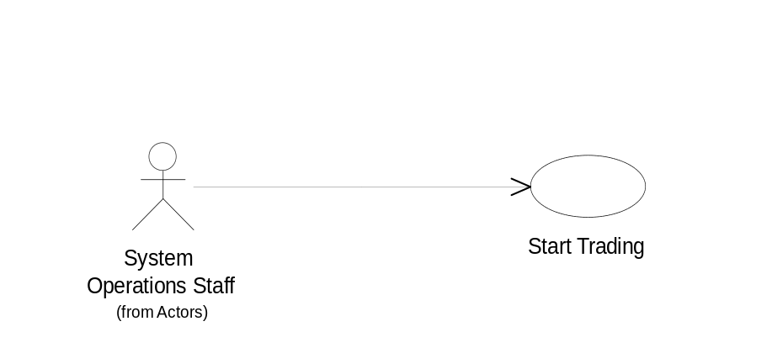

Special Requirements

Performance

Security
- The command to initiate this process can only be entered from the operators console.

Preconditions
- Trading has not already been started
- Enter product open interest has completed.
- Disseminate Auto Trader eligible products has completed.
- Synchronize product data has completed.

Postconditions
- All processes dependent upon trading started can not be run.

Pictures of the User Interface

2.1.16 Stop Trading

Brief Description
This use case models the required interactions between the System Operator and the Trading Engine software when trading is stopped.

Flow of Events

Basic Flow
- Systems operations enters the command to stop trading.
- The system validates the request.
- The system enters the stop trading state.
- The system logs that trading has stopped.
- The system responds to the operators.

Alternative Flows

System not eligible to enter stop trading state.
- System operations enters the command to stop trading.
- The system validates the request.
- The system responds with an error indicating that trading cannot be stopped. The response includes the reason trading cannot be stopped (function not complete, trading not started, etc.).

Relationships

Actors:
System Operations Staff

Uses and extends associations with:

Use-Case Diagrams

Stop Trading UCD
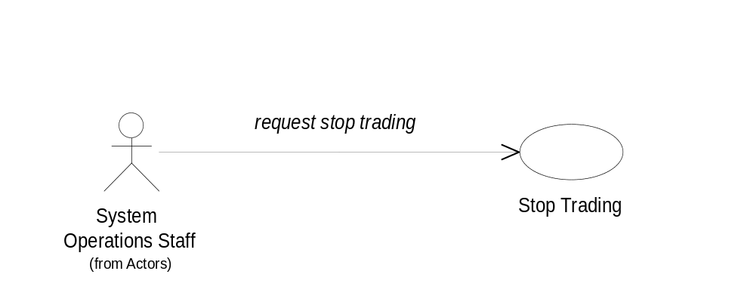

Special Requirements

Performance

Security
- The command to initiate this process can only be entered from the operators console.

Preconditions
- Trading has not already been stopped.

Postconditions
- All processes dependent upon trading being stopped cannot be run.

Pictures of the User Interface

2.1.17 Synchronize Membership Data

Brief Description
This use case models the interaction of the System Operator and the Trade engine when updated membership data is retrieved from the Membership System.

Flow of Events

Basic Flow
- The system operations staff initiates the Synchronize Membership Data function from the system console.
- The system validates the request.
- The system initiates a connection to the membership system
- The system begins the Synchronize Membership Data function
- The system logs all updates, additions, and deletions from the membership system.
- The system notifies the operators when the Synchronize Membership Data function completes.

Alternative Flows

Membership System unavailable.
- The system initiates a connection to the membership system
- The system notifies the systems operations staff that the membership system is not available.

Relationships

Actors:
System Operations Staff
Membership System

Uses and extends associations with:

Use-Case Diagrams

Synchronize Membership Data UCD
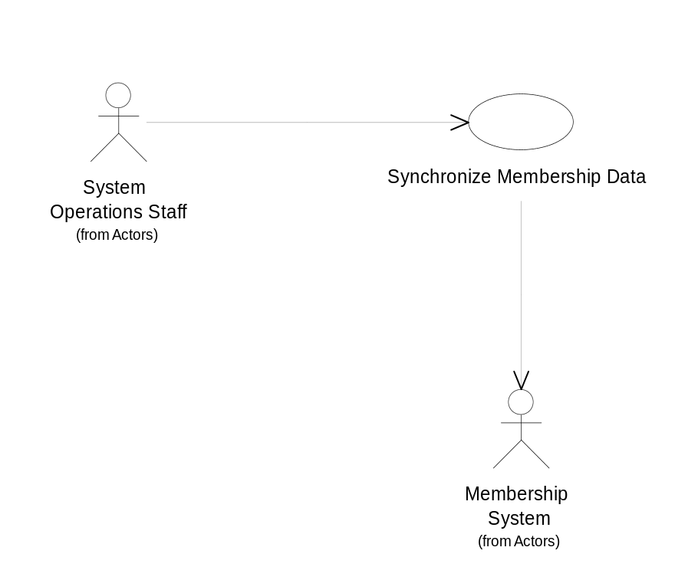

Special Requirements

Performance
- The Synchronize Membership Data function must be completed within xx minutes from the time it is initiated.

Security

Preconditions

Postconditions

Pictures of the User Interface

2.1.18 Synchronize Product Data

Brief Description
This use case models the required interactions between the Trading Engine and an external product data system when new product data is needed.

Flow of Events

Basic Flow
- The Systems Operator enters the Synchronize Product Data command on the system console
- The system contacts the Integrated Product Service and begins the synchronization process.
- The systems logs all updates, additions, and deletions.
- The system provides status messages to the operators.
- The system provides a completion message to the operators.

Alternative Flows

Relationships

Actors:
System Operations Staff

Uses and extends associations with:

Use-Case Diagrams

Synchronize Product Data UCD
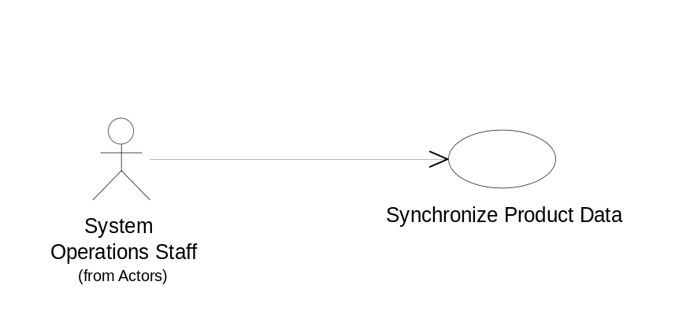

Special Requirements

Performance
The Synchronize Product Data function must be completed within xx minutes from the time that it is started.

Security
The Synchronize Product Data function can only be initiated from the system console.

Preconditions

Integrated Product Service is available

Postconditions

Functions dependent upon the completion of the Synchronize Product Data functions can be initiated.

Pictures of the User Interface

2.1.19 Update Product External Last Sale

Brief Description
This use case models the interaction between TIPS and the Trade Engine when TIPS send last sale data for products.

Flow of Events

Basic Flow
- The TIPS system sends an external last sale price to the system
- The system validates that the product exists.
- The system updates the product with the external last sale.

Alternate Flows

Update Product External Last Sale for Unknown Product
- The TIPS system sends an external last sale price to the system
- The system is unable to validates that the product exists.
- The system is logs an error message to the system log that the product is unknown.

Relationships

Actors:
TIPS

Uses and extends associations with:

Use-Case Diagrams

Update Product External Last Sale UCD
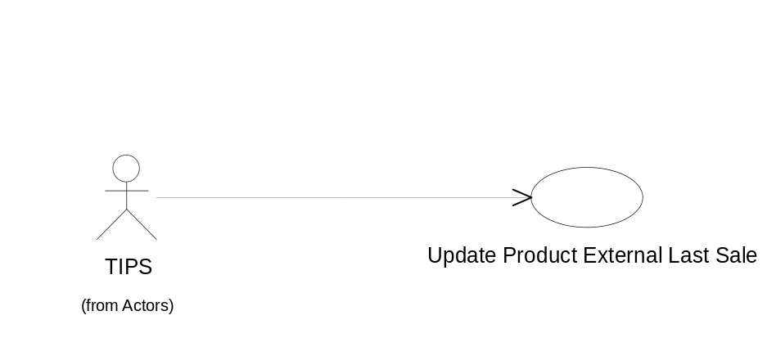

Special Requirements

Performance
- The system must be able to handle xx external last sale update messages per second.

Security

Preconditions

Postconditions

Pictures of the User Interface

